Situation :

Please refer to the NAT Gateway - document before going through this.

sk;

Instead of NAT Gateway, use NAT instance and connect to internet

Steps:

* Create a NAT instance
  + Instead of selecting usual Ec2 instance, we have to select NAT instance in community AMI
* Select public subnet
* Security group , we have to add as mentioned below

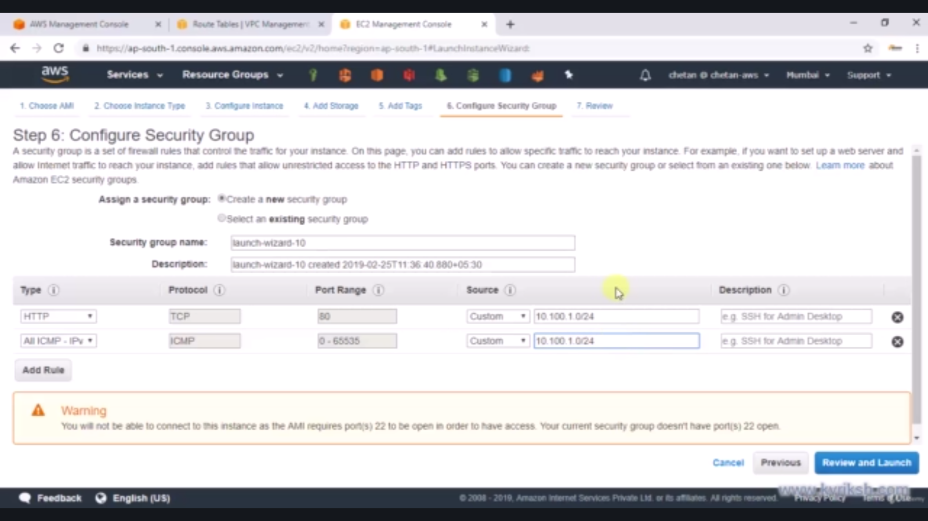

* Disable source/destination check
* Change the machine 2 route table and add entry to this nat instance

Now if you SSH to the machine 2 , you should be able to connect to internet

